QUESTION BANK

DISCRETE MATHEMATICS

SHORT ANSWER QUESTIONS

1.Define Partially Ordered set.

2.What is Binomial Coefficient? And write Binomial theorem formula.

3.Explain about multinomial theorem ?Find the coefficient of x^2 y^3 z^4 w in the expansion of 〖(x+y+z-w)〗^10

4.Define the following.

i)Walk,

ii)Circuit,

iii)Path.

iv)Cycle.

5) Define Hamilton path, Hamilton Circuit.

6) Define Lattice and write it’s properties

7) Difference between Permutation and Combination.

8) From a Group of 10 professors. How many ways can a committee of 5 members are formed so that at least one professor A and professor B will be included?

9) Define the following.

a) Bipartite graph k(1,3).

b) Regular Graph.

c) Planar Graph.

d) Spanning sub graph.

10) Define Graph Colouring, and chromatic Number with an example.

Unit -3

LONG ASWER TYPE QUESTIONS

1) Define the Following.

a) Lattice.

b) Complemented Lattice.

c) Semi Lattice.

d) Distributive Lattice

With Examples Each.

2) What is Cycle Group? Check whether The multiplicative Group G = { 1, -1, i, -i } is cyclic generated by i and -i.?

11) What is Hasse Diagram?Draw the Hasse diagram for the following POSET for ({1,2,3,4,5,6}, /)

12) Consider the poset A = {a, b, c, d, e, f, g} be ordered shown in fig. Also let B = {c, d, e}. Determine the upper and lower bound of B

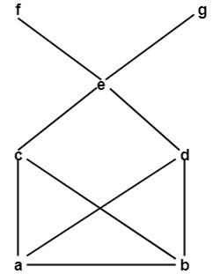

UNIT_4

3) If C(n,x)=56 and P(n,x)=336 Find The value of n and x?

4) Find the number of permutations that can be had from the letters of the word DAUGHTER?

a ) Vowels being always together.

b ) Not all vowels together.

c) Not even two vowels together.

d) Vowels Occupying Even places.

5) Write about Pigeonhole principle with an example and state its properties.

6) How many 4-digit numbers can be formed by using the digits 1 to 9 if repetition of digits is not allowed?

13) A committee of 8 is to be formed from 16men and 10 women. In how many ways can committee be formed if

a) There must be 4 men and 4 women

b) There should be even number of Women

c) More Women than Men

d) Atleast 6 men

14) In How many ways 20 similar books be placed on 5 different shelves?

15) Find the Number of Integers less than 500 and divisible by 9 or 11 or 13?

16) Discuss briefly about Pigeon hole Principle with an suitable examples.

**UNIT-5**

7) Short Notes on

a)Chromatic Numbers

b)Hamiltonian Graph

c)Spanning Trees

d)Euler’s Formulae.

8) State Whether the following graph has a Hamilton circuit? If yes then check whether it is a Hamilton Graph or not?

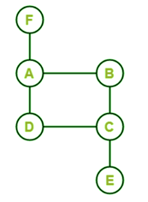

9) Differentiate Planar and Non-planar graphs with suitable examples

10) Find Minimal Spanning Tree for the following graph using Krushkal’s Algorithm?

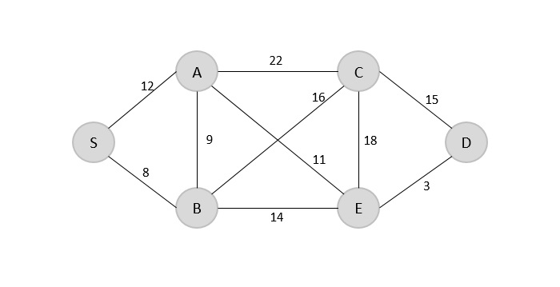

17) Briefly explain Isomorphism and tell wheter the following graphs are isomorphic or not?

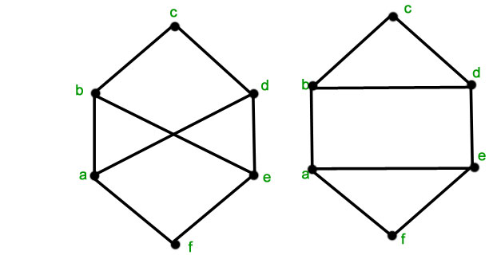

18) Short Notes on Euler’s Formula, Multi-graphs and Euler Circuit with suitable Examples unit-5

19) Using DFS Algorithm for the following graph find out Spanning tree?

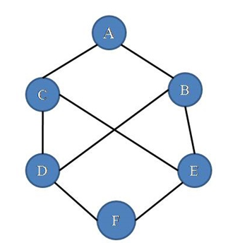

20) Find Out Minimal Spanning Tree for following graph using Prim’s Algorithm?

